**MICROSERVICES WITH API GATEWAY**

cd D:\123456\microservices\account

mvn clean package

**src/main/java/com/cognizant/account/controller**

package com.cognizant.account.controller;

import org.springframework.web.bind.annotation.*;

import java.util.Map;

import java.util.HashMap;

@RestController

@RequestMapping("/accounts")

public class AccountController {

@GetMapping("/{number}")

public Map<String, Object> getAccount(@PathVariable String number) {

Map<String, Object> account = new HashMap<>();

account.put("number", number);

account.put("type", "savings");

account.put("balance", 234343);

return account;

}

}

<http://localhost:8080/accounts/00987987973432>

**OUTPUT:**

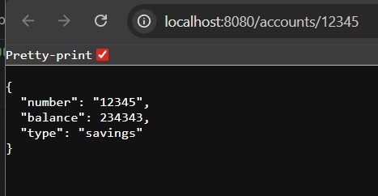

**D:\123456\microservices\**

**src/main/resources/application.properties**

server.port=8081

**src/main/java/com/cognizant/loan/controller**

package com.cognizant.loan.controller;

import org.springframework.web.bind.annotation.*;

import java.util.Map;

import java.util.HashMap;

@RestController

@RequestMapping("/loans")

public class LoanController {

@GetMapping("/{number}")

public Map<String, Object> getLoan(@PathVariable String number) {

Map<String, Object> loan = new HashMap<>();

loan.put("number", number);

loan.put("type", "car");

loan.put("loan", 400000);

loan.put("emi", 3258);

loan.put("tenure", 18);

return loan;

}

}

[**http://localhost:8081/loans/H00987987972342**](http://localhost:8081/loans/H00987987972342)

